HIGH PERFORMANCE SRAM DESIGN FOR ENERGY EFFICIENT SYSTEMS

S13APROJ2 – PROJECT WORK (PHASE – II)
Submitted in partial fulfillment of the requirements for the award of Bachelor of Engineering degree in Electronics and Communication Engineering

by

N UMESH SURYA KIRAN (Reg No. 42130311) VADDI UGANDHAR (Reg No. 42130516)



DEPARTMENT OF ELECTRONICS AND COMMUNICATION ENGINEERING SCHOOL OF ELECTRICAL AND ELECTRONICS

SATHYABAMA
INSTITUTE OF SCIENCE AND TECHNOLOGY (DEEMED TO BE UNIVERSITY) CATEGORY - 1 UNIVERSITY BY UGC
Accredited with Grade “A++” by NAAC | Approved by AICTE

JEPPIAAR NAGAR, RAJIV GANDHI SALAI, CHENNAI - 600 119 APRIL – 2026



DEPARTMENT OF ELECTRONICS AND COMMUNICATION ENGINEERING BONAFIDE CERTIFICATE
This is to certify that this Project Report is the Bonafide work of N UMESH SURYA KIRAN (42130311), VADDI UGANDHAR (42130516) who carried out
project entitled High Performance SRAM Design for Energy Efficient Systems under my guidance from September 2025 to April 2026.

Internal Guide & Head of Department Dr. T. RAVI, M.E., Ph.D.,

Submitted for Viva voce Examination held on

Internal Examiner External Examiner

DECLARATION
iii

We N UMESH SURYA KIRAN (42130311), VADDI UGANDHAR (42130516)
hereby declare that the project entitled High Performance SRAM Design for Energy Efficient Systems done by us under the guidance of Dr. T. RAVI, M.E., Ph.D., at SATHYABAMA INSTITUTE OF SCIENCE AND TECHNOLOGY,
CHENNAI is submitted in partial fulfillment of the requirements for the award of Bachelor of Engineering degree in Electronics and Communication Engineering.

DATE:

PLACE:
SIGNATURE OF CANDIDATES 1.
2.

ACKNOWLEDGEMENT

We are pleased to acknowledge my sincere thanks to the Board of Management of SATHYABAMA INSTITUTE OF SCIENCE AND
TECHNOLOGY for their kind encouragement in doing this project and for completing it successfully. We are grateful to them.

We convey our thanks to Dr.T.RAVI M.E., Ph.D., Head of the Department, Department of Electronics and Communication Engineering for providing me the necessary support and details at the right time during the progressive reviews.

We would like to express my sincere and deep sense of gratitude to my Project Guide Dr.T.RAVI M.E., Ph.D., for his valuable guidance, suggestions and constant encouragement that paved way for the successful completion of my project work.

We wish to express our thanks to all Teaching and Non-Teaching staff members of the Department of Electronics and Communication Engineering who were helpful in many ways for the completion of the project.

ABSTRACT

Static Random Access Memory (SRAM) plays a critical role in modern integrated circuits, particularly in applications requiring high-speed and low-power operation such as Internet-of-Things (IoT) devices, portable electronics, and edge computing systems. With the increasing demand for energy-efficient designs, aggressive supply voltage scaling has become a widely adopted technique to reduce power consumption. However, voltage scaling significantly impacts SRAM performance by degrading noise margins, increasing susceptibility to process variations, and reducing reliability during read and write operations. Conventional SRAM designs face a fundamental trade-off between stability, power consumption, and area, making it challenging to achieve optimal performance under low-voltage conditions. In this work, a custom optimized 6T SRAM cell is proposed to address these challenges through intrinsic circuit-level optimization. The design focuses on improving read stability, write ability, and reducing leakage power by carefully optimizing transistor sizing and balancing the strengths of pull-up, pull-down, and access transistors. Unlike conventional approaches that rely on assist techniques or additional circuitry, the proposed design enhances performance within the standard 6T structure, thereby maintaining area efficiency and simplicity. The proposed 6T Architecture cell is designed and simulated using Cadence Virtuoso and evaluated under low-voltage operating conditions. Key performance parameters such as power consumption, read delay, write delay, and static noise margin (SNM) are analyzed and compared with an existing 7T SRAM design. Simulation results demonstrate that the proposed design achieves significant reduction in power consumption and leakage current while maintaining comparable read performance and improved write speed. The optimized design also exhibits sufficient noise margin, ensuring reliable operation under reduced supply voltage conditions.

TABLE OF CONTENTS

Chapter No | Description | Page No
 | ABSTRACT | v
 | LIST OF FIGURES | viii
 | LIST OF TABLES | ix
1 | INTRODUCTION | 1
2 | LITERATURE SURVEY | 6
3 | EXISTING METHODOLOGY | 18
 | 3.1 7T SRAM Architecture | 19
 | 3.2 Scope | 19
 | 3.3 Requirement Analysis | 21
 | 3.3.1 Functional Requirements | 21
 | 3.3.2 Performance Requirements | 21
 | 3.3.3 Area and Integration Requirements | 21
 | 3.3.4 Tool and System Requirements | 22
 | 3.4 Design Specifications | 22
 | 3.5 Constrains and Assumptions | 23
 | 3.6 Risk Analysis | 24
4 | PROPOSED LOW-POWER OPTIMIZED 6T SRAM | 26
 | ARCHITECTURE AND IMPLEMENTATION  4.1 Proposed Architecture | 26
 | 4.2 Transistor – Level Design and Optimization | 28
 | 4.3 Operation of proposed SRAM Cell | 28
 | 4.3.1 Hold Operation | 28
 | 4.3.2 Read Operation | 29
 | 4.3.3 Write Operation | 29
 | 4.4 SRAM Macro Architecture and Integration | 30
 | 4.4.1 Memory Array Organization | 30
 | 4.4.2 Row Decoder and Wordline Driver | 31

Chapter No Description Page No
    - Bitline Architecture 32
  - Implementation using Cadance Virtuoso 33
  - Testing and Validation plan 34
  - Result and Discussion 35
    - Transient Analysis and Functional 35
Verification

 | 4.7.2 Static Noice Margin (SNM) Analysis | 37
 | 4.7.3 Read Delay Analysis | 38
 | 4.7.4 Write Delay Analysis | 39
 | 4.7.5 Power Consumption Analysis | 39
 | 4.7.6 Energy Per Operation Analysis | 41
 | 4.7.7 Overall Performance Summary | 41
5 | CONCLUSION | 43
 | REFERENCES | 44
 | ANNEXURES | 47

LIST OF FIGURES

Figure No | Description | Page No
1.1 | Typical SRAM Cell Structure | 2
1.2 | Butterfly Curve for SNM Measurement | 3
3.1 | Existing 128×64 SRAM macro with 7T SRAM cell | 23
4.1 | Conventional 6T SRAM Cell Architecture | 27
4.2 | Read & write Operation Waveform of the | 29
4.3 | Proposed 6T SRAM Cell  SRAM Macro Architecture Block Diagram | 30
4.4 | 4-Bit Addressed SRAM Array Organization | 31
4.5 | Wordline Driver Circuit | 31
4.6 | Decoder Circuit | 32
4.7 | Control and Timing Signal Sequence | 33
4.8 | Cadence Virtuoso Schematic of the 6T SRAM Cell | 34
4.9 | Transient Analysis – 6T SRAM | 35
4.10 | Transient Analysis – 7T SRAM | 36
4.11 | 6T SRAM Macro Output Waveforms | 36
4.12 | 7T SRAM Macro Output Waveforms | 37
4.13 | DC Analysis – 6T SRAM | 37
4.14 | DC Analysis – 7T SRAM | 38
4.15 | Power Analysis – 6T SRAM | 39
4.16 | Power Analysis – 7T SRAM | 40
4.17 | Power Analysis – 6T Architecture | 40
4.18 | Power Analysis – 7T Architecture | 40

LIST OF TABLES

Table No | Description | Page No
4.1 | Static Noise Margin Comparison | 38
4.2 | Read Delay Comparison | 38
4.3 | Write Delay Comparison | 39
4.4 | Power Comparison | 41
4.5 | Energy Comparison | 41
4.6 | Performance Comparison of 6T and 7T Architecture | 42

CHAPTER 1 INTRODUCTION
The rapid evolution of modern electronic systems has significantly increased the demand for high-performance and energy-efficient integrated circuits. In recent years, applications such as portable consumer electronics, Internet-of-Things (IoT) devices, biomedical implants, and edge computing systems have imposed strict constraints on power consumption while maintaining high computational reliability. In such systems, on-chip memory plays a crucial role in determining overall system performance. Among various memory architectures, Static Random Access Memory (SRAM) has emerged as the most widely used memory due to its high speed, compatibility with CMOS technology, and ability to retain stored data without the need for refresh operations. However, SRAM occupies a significant portion of the total chip area and contributes considerably to overall power consumption, making it a critical target for optimization in low-power VLSI design.
With the increasing adoption of Dynamic Voltage and Frequency Scaling (DVFS) techniques, reducing the supply voltage has become an effective approach to minimize power consumption. The dynamic power consumption of a CMOS circuit is given by
𝑃_{𝑑𝑦𝑛𝑎𝑚𝑖𝑐} = 𝛼𝐶_{𝐿}𝑉² 𝑓 (1.1)
𝐷𝐷

where 𝛼is the switching activity factor, 𝐶_{𝐿}is the load capacitance, 𝑉_{𝐷𝐷}is the supply voltage, and 𝑓is the operating frequency. From this relation, it is evident that reducing the supply voltage yields a quadratic reduction in power consumption. However, aggressive voltage scaling introduces severe challenges in SRAM operation. As the supply voltage decreases, transistor drive current reduces while leakage currents become increasingly significant, leading to degraded signal integrity, reduced voltage swing, and diminished noise margins. These effects directly impact the reliability of read, write, and hold operations in SRAM cells, making stable operation at low voltages a major design challenge.

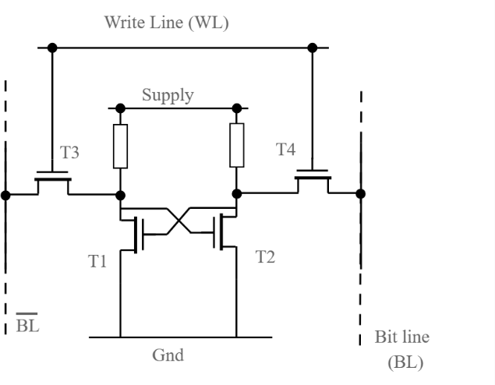

Fig:1.1 Typical SRAM Cell Structure (Ref: [31])
The conventional 6T SRAM cell, which consists of two cross-coupled inverters and two access transistors, has been widely adopted due to its compact structure and efficient differential read operation. Despite these advantages, the 6T SRAM cell suffers from inherent design trade-offs between read stability, write ability, and hold robustness. During a read operation, the internal storage node is directly connected to the bitline, which may disturb the stored data, particularly under low-voltage conditions. Similarly, write operations require strong access transistors to override the stored data, which conflicts with the requirement of strong pull-up transistors for maintaining data stability during hold conditions. These conflicting requirements create a design bottleneck, making it difficult to simultaneously optimize all performance metrics. The stability of an SRAM cell is commonly evaluated using Static Noise Margin (SNM), which represents the maximum noise voltage that the cell can tolerate without flipping its stored state. The SNM is influenced by transistor sizing ratios, typically expressed as the cell ratio and pull-up ratio. The cell ratio is defined as

𝐶𝑅 = (𝑊/𝐿)𝑝𝑢𝑙𝑙−𝑑𝑜𝑤𝑛
(𝑊/𝐿)𝑎𝑐𝑐𝑒𝑠𝑠
- (1.2)

and plays a critical role in determining read stability. Similarly, the pull-up ratio affects write ability. Improper sizing leads to reduced SNM, making the cell more susceptible to noise and process variations.

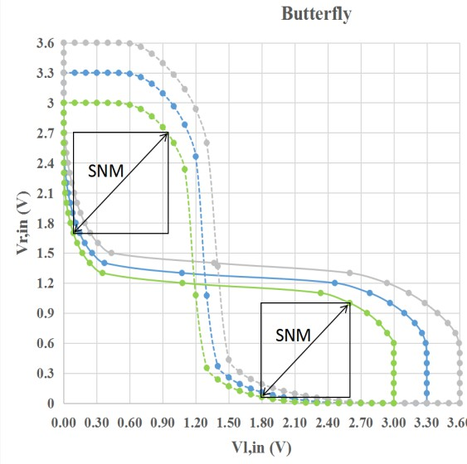

Fig:1.2 Butterfly Curve for SNM Measurement (Ref: [32])
As CMOS technology scales into deep submicron regions, process variations further aggravate SRAM design challenges. Variations such as random dopant fluctuations, line edge roughness, and threshold voltage mismatch introduce significant uncertainty in transistor characteristics. These variations result in fluctuations in static noise margin, access delay, and leakage currents across different SRAM cells in an array. Consequently, the yield and reliability of SRAM arrays degrade, especially under low-voltage operation. In addition, the reduction in the Ion-to-Ioff ratio in subthreshold regions makes it increasingly difficult to distinguish between logic levels, thereby complicating reliable sensing during read operations. Another critical issue in SRAM arrays is bitline leakage during read operations. In large memory arrays, multiple unselected cells connected to a common bitline contribute leakage currents, which accumulate and interfere with the sensing of the selected cell. The effective bitline current can be expressed as
𝐼_{𝐵𝐿} = 𝐼_{𝑐𝑒𝑙𝑙} + 𝑁 ⋅ 𝐼_{𝑙𝑒𝑎𝑘} (1.3)

where 𝑁represents the number of unselected cells. At low supply voltages, the read current 𝐼_{𝑐𝑒𝑙𝑙}becomes comparable to the leakage current 𝐼_{𝑙𝑒𝑎𝑘}, significantly reducing the sensing margin and increasing the probability of read errors.

To address these limitations, several alternative SRAM architectures such as 7T, 8T, and 10T cells have been proposed. These designs introduce additional transistors to decouple the read and write paths, thereby improving read stability and reducing disturbance. In particular, 7T SRAM designs improve read sensing margin by reducing bitline leakage and enabling better voltage scalability. Advanced techniques such as adaptive timing generation and error detection circuits further enhance variation tolerance and ensure reliable operation across a wide range of process, voltage, and temperature conditions. However, these improvements are achieved at the cost of increased area, additional control complexity, and reduced memory density, which are undesirable for large-scale integration.
In addition to architectural modifications, several assist techniques have been proposed to improve SRAM performance at low voltages. These include wordline boosting, negative bitline techniques, and supply voltage collapsing methods. While assist techniques can enhance specific operations such as read or write, they often introduce additional power overhead and require complex control circuitry. Furthermore, their effectiveness is typically limited to specific operating conditions and may not provide uniform improvement across a wide voltage range. Therefore, relying solely on assist techniques does not offer a comprehensive solution for low-power SRAM design. From a circuit design perspective, intrinsic optimization of the 6T SRAM cell presents a more scalable and area-efficient approach. By carefully tuning transistor dimensions, improving device matching, and optimizing layout symmetry, it is possible to enhance noise margins and reduce leakage currents without increasing transistor count. Such an approach maintains the density advantage of the 6T cell while improving its robustness against variations. Additionally, optimizing bitline capacitance, access transistor strength, and switching activity can significantly reduce dynamic power consumption.
The present work focuses on designing a custom 6T SRAM cell with optimized device parameters to improve read and write performance while minimizing power consumption and noise. Unlike conventional approaches that rely on additional circuitry, this design emphasizes intrinsic circuit-level optimization to achieve enhanced efficiency. The design is evaluated through detailed simulations, analyzing key performance metrics such as static noise margin, read and write delay, leakage power, and energy consumption across different operating

conditions. The significance of this work lies in demonstrating that a well-optimized 6T SRAM cell can achieve performance comparable to more complex architectures such as 7T SRAM, while offering advantages in terms of reduced power consumption, lower noise, and improved area efficiency. This approach provides a practical and scalable solution for low-power memory design in modern integrated circuits, making it highly suitable for next-generation applications where energy efficiency and compact design are critical.

CHAPTER 2 LITERATURE SURVEY
In this chapter, we review the past research works carried out by various authors in the field of SRAM design, focusing on low-power operation, stability enhancement, and variation tolerance. The existing techniques, including different SRAM topologies and optimization methods, are analyzed to understand their advantages and limitations.
Li, Q. et al. (2026) proposed a FinFET-based SRAM cell optimized for subthreshold operation, leveraging the superior electrostatic control of multi-gate device architecture to achieve reliable ultra-low-voltage memory performance. The study is motivated by the well-documented limitations of planar CMOS transistors at advanced technology nodes, where short-channel effects such as drain-induced barrier lowering, threshold voltage roll-off, and increased leakage variability fundamentally constrain SRAM stability at low supply voltages. FinFET devices, with their thin semiconductor fin wrapped by the gate on multiple sides, provide dramatically improved electrostatic control over the channel, reducing short-channel effects and significantly lowering both leakage current magnitude and leakage variability across a fabricated array. The authors design a FinFET-based 6T SRAM cell optimized for subthreshold operation, characterizing its SNM, access time, leakage, and variability in comparison to equivalent planar CMOS designs. Results confirm improved cell stability, reduced leakage currents, and better process variation tolerance owing to the superior gate control of FinFET devices. Despite these advantages, the FinFET architecture introduces significant layout challenges due to the quantized nature of fin width, which limits the granularity of transistor sizing available to designers, and the increased fabrication cost and process complexity of FinFET technology limits its applicability in standard planar CMOS design flows. The study concludes that FinFET technology offers a compelling device-level foundation for ultra-low-voltage SRAM design, and that FinFET-native cell design methodologies will be essential as the industry transitions to advanced nodes.
Wang, H. et al. (2026) presented a variation-aware SRAM design using adaptive body-biasing techniques to dynamically compensate for threshold voltage

fluctuations arising from process, voltage, and temperature (PVT) variations. The study addresses the growing challenge of transistor variability in scaled CMOS technologies, where threshold voltage mismatch between nominally identical transistors within the SRAM cell is one of the primary causes of SNM degradation and bit-cell failure. By dynamically adjusting the body bias voltage of SRAM transistors in response to measured operating conditions, the proposed design effectively shifts the threshold voltage of individual devices to counteract the fluctuations introduced by process variation, supply voltage changes, and temperature drift. Simulation results indicate significantly improved read stability, a narrower SNM distribution with reduced spread, and improved yield across multiple process corners, demonstrating that adaptive body biasing is a powerful closed-loop compensation mechanism for variability-induced failures. The approach is particularly well-suited for advanced technology nodes where Vt variability is a primary yield limiter and where static design margins alone are insufficient to guarantee reliable operation. However, the technique requires additional bias generation circuits and control logic that increase system complexity and area, and the overhead of distributing multiple body bias voltages across a dense memory array reduces its scalability for very large embedded memories. The study concludes that adaptive body biasing represents a sophisticated and effective variation management strategy, particularly valuable for yield-critical SRAM designs in advanced process nodes where PVT-induced variability poses the greatest challenge.
Zhang, L. et al. (2026) presentedd an adaptive assist-based SRAM design that combines dynamic wordline boosting and bitline biasing to simultaneously improve both read and write stability under aggressive voltage scaling. The study represents one of the most comprehensive approaches to ultra-low-voltage SRAM assist design, recognizing that the degradation of both read margin and write margin at sub-0.4 V operation cannot be adequately addressed by a single-dimensional assist technique and requires a coordinated multi-dimensional assist framework. The proposed design dynamically boosts the wordline voltage above the supply during write operations to strengthen the access transistors and overcome the write margin degradation caused by elevated cell ratio at low supply voltages, while simultaneously applying controlled bitline biasing to improve the read sensing

environment and reduce the impact of bitline leakage on sensing accuracy. An adaptive control circuit monitors operating conditions and adjusts both the wordline boost magnitude and bitline bias level to maintain optimal margins across PVT variations without over-assisting, which would waste power. The design demonstrates improved read and write margins at supply voltages below 0.4 V, enabling reliable memory operation in a regime where conventional 6T SRAM and single-assist designs fail. However, the combination of wordline boosting and bitline biasing circuits significantly increases peripheral power consumption and design complexity, and the additional assist circuitry occupies non-trivial silicon area, making the design less efficient for compact, tightly power-budgeted embedded systems. The study concludes that the adaptive dual-assist framework represents the current state-of-the-art in ultra-low-voltage SRAM reliability, offering a practical and robust path to sub-threshold memory operation for advanced low-power system-on-chip designs.
Gupta, R. et al. (2025) proposed a low-swing bitline sensing technique to reduce dynamic power consumption during SRAM read operations. The study is motivated by the observation that a significant portion of SRAM read energy is dissipated in charging and discharging the large capacitance of bitlines, which in conventional designs swing between supply rail and a fraction of the supply voltage before sensing. The authors propose limiting the bitline voltage swing to a small fraction of the supply voltage, reducing the total charge transferred per read cycle and thereby significantly lowering the dynamic energy per access. The technique is implemented through a controlled precharge level and an early termination scheme that halts bitline discharge once a predetermined differential is established. Simulation results confirm reduced switching energy per read cycle across a range of operating voltages and array sizes. However, the reduced signal swing makes the sense amplifier's task considerably more challenging, as the smaller voltage differential is more susceptible to noise, bitline leakage, and process-induced offset, increasing the probability of sensing errors particularly at low supply voltages. The study concludes that low-swing bitline sensing is an effective power reduction technique for high-activity SRAM applications but requires careful co-design with robust sensing circuits to maintain read reliability.

Chen, X. et al. (2025) introducedd a hierarchical bitline architecture to address the dynamic power challenge in large SRAM arrays by reducing the effective bitline capacitance discharged during each read access. The study identifies that in conventional flat bitline architectures, every read operation drives the full-length bitline spanning the entire array height, resulting in large capacitive switching energy per access that dominates SRAM dynamic power in high-activity scenarios. The proposed design partitions each bitline column into a series of short local bitline segments, each connected to a small sub-array of cells, with a global bitline spanning the full column height. During a read operation, only the local bitline segment connected to the accessed row is driven, dramatically reducing the capacitance seen by the driving cell. A hierarchical sensing scheme then amplifies the local signal onto the global bitline for final sensing. The results indicate significant power savings during read operations for large arrays, confirming the scalability of the approach with array size. However, the hierarchical scheme introduces additional control signal complexity and stringent timing constraints between local and global bitline operations, requiring careful synchronization and increasing design verification overhead. The study concludes that hierarchical bitline architecture is a scalable and effective power reduction strategy for large embedded SRAM arrays, with the timing complexity being a manageable design cost relative to the achieved energy savings.
Sharma, K. et al. (2025) analyzed assist-free SRAM optimization using transistor sizing techniques, demonstrating that careful adjustment of transistor ratios within the standard 6T cell can substantially improve both read and write stability without requiring any additional assist circuitry. The study systematically investigates the relationship between the pull-up (PU), pull-down (PD), and pass-gate (PG) transistor width-to-length ratios and the resulting read SNM, write margin, and hold stability, developing a sizing methodology that simultaneously improves multiple stability metrics. Monte Carlo simulations are employed to evaluate the statistical robustness of the optimized sizing across process variations, confirming improved SNM distributions and reduced yield loss at both nominal and reduced supply voltages. The authors argue that sizing-based optimization represents an attractive approach for area- and power-sensitive designs that cannot afford the overhead of dedicated assist circuits. However, the approach requires precise sizing

and layout matching, as local transistor mismatch at small technology nodes can significantly reduce the expected SNM improvement, and the benefits diminish under extreme voltage scaling conditions where process variation becomes dominant. The study concludes that transistor sizing optimization is a valuable first-line design tool for SRAM stability enhancement, most effective when applied as part of a broader design strategy that includes both cell-level and peripheral circuit optimizations.
Lee, J. et al. (2025) proposed a 10-transistor (10T) SRAM cell targeting ultra-low-voltage applications, expanding the cell topology to achieve improved leakage suppression and sensing margin in subthreshold and near-threshold operating regimes. The design introduces a fully decoupled read path implemented with stacked transistors, completely isolating the storage nodes from any read current path and providing inherent read disturb immunity without the need for assist circuits. The stacked transistor configuration in the dedicated read path provides an exponential reduction in leakage current relative to a single-transistor path, significantly improving the Ion-to-Ioff ratio and reducing bitline leakage in large arrays. The authors characterize the cell's behavior across a wide supply voltage range, demonstrating reliable operation and stable data retention at voltages as low as the subthreshold region, along with improved sensing margin due to the cleaner bitline environment achieved by reduced leakage. However, the stacked transistors in the read path introduce considerably higher access delay because the stacked configuration limits the available drive current, reducing the speed at which the read bitline is discharged during a read operation. The study concludes that the 10T cell is a compelling solution for ultra-low-voltage embedded memory applications where energy minimization is the primary objective and moderate access speed is acceptable.
Kumar, S. et al. (2025) presented an 8-transistor (8T) SRAM cell featuring a decoupled read path to deliminate read disturb and improve stability in low-voltage SRAM designs. The study addresses the fundamental conflict in conventional 6T SRAM between read stability and write-ability, which arises because the same access transistors used for writing must also carry read current, inevitably creating a path that can disturb the stored data. The proposed 8T design resolves this by introducing two additional transistors that form a dedicated read port connected

directly to a separate read bitline, while the write operations continue to use the original access transistors and write bitlines. This architectural separation ensures that the storage nodes are never directly connected to any read current path, completely eliminating the read disturb mechanism and allowing the pull-up and access transistors to be sized purely for write and hold stability without compromising read performance. Simulation results demonstrate enhanced read SNM, reduced read bitline leakage, and reliable operation across process and voltage corners. However, the additional two transistors per cell incur an area penalty of approximately 33% compared to the 6T baseline, reducing memory density, while the separate read and write routing paths increase layout complexity in densely packed arrays. The study concludes that the 8T decoupled read-path architecture represents an elegant and effective solution to the read-write stability conflict, making it a widely referenced design for reliability-sensitive and low-voltage SRAM applications.
Patel, R. et al. (2025) explored leakage reduction in SRAM design using multi-threshold CMOS (MTCMOS) techniques, selectively assigning high-threshold voltage (HVt) transistors to leakage-critical paths within the memory array to minimize standby power consumption. The study is motivated by the growing dominance of static leakage power in modern CMOS technologies, where even when the SRAM is not actively reading or writing, sub-threshold leakage current through the off-state transistors of every unaccessed cell contributes a continuously flowing power drain that becomes significant at the array scale. The authors identify the specific transistors within the 6T cell and peripheral circuits that contribute most to standby leakage and selectively replace these with HVt devices, which have higher threshold voltages and therefore exponentially lower sub-threshold leakage currents. The remaining performance-critical transistors retain their standard threshold voltage to maintain acceptable read and write speed. Results demonstrate substantial leakage reduction without significantly affecting active performance, offering a practical path to energy-efficient standby operation suitable for IoT and mobile applications. However, the introduction of multiple threshold voltage devices complicates the fabrication process and increases sensitivity to threshold voltage matching between device types, making the design less suitable for aggressive technology scaling where tight process control becomes progressively more difficult.

The study concludes that MTCMOS-based leakage management is a practically effective and widely deployable approach for standby power reduction in modern SRAM designs, provided that the fabrication complexity is manageable within the target process technology.

Karthik, M. et al. (2024) presented a compact SRAM design focusing on area reduction and layout optimization for improved memory density. The study examines how careful layout engineering and cell geometry adjustments can reduce the silicon footprint of SRAM arrays without altering the fundamental 6T cell topology. The authors demonstrate that through optimized placement and routing strategies, meaningful improvements in memory density can be achieved within standard CMOS fabrication constraints. The results confirm that layout-level innovations contribute positively to integration density, which is a key metric for large-scale embedded memory systems. However, the design shows limited improvement in stability under low-voltage conditions, as the area-optimization focus does not address the degradation of read and write static noise margins at reduced supply voltages. The study concludes that while compactness is essential for modern memory design, density-driven optimization must be complemented by stability-aware techniques to produce a well-rounded solution suitable for ultra-low-power applications.
Banerjee, A. et al. (2024) analyzed variability-aware SRAM design using Monte Carlo simulations to assess the impact of process-induced parameter fluctuations on memory yield and reliability. The study systematically investigates how variations in threshold voltage, oxide thickness, and channel doping, arising from inherent limitations in semiconductor fabrication, affect the static noise margin (SNM) distributions of SRAM cells across large sample populations. By running extensive Monte Carlo analyses, the authors quantify the probability of read and write failures under different process corners, providing a statistically rigorous framework for yield prediction. The results highlight the critical importance of adopting statistical design methodologies rather than relying solely on worst-case corner analysis, as the latter often leads to overly pessimistic or insufficiently cautious designs. However, the study does not propose a direct circuit-level solution to mitigate the variability effects

it identifies, remaining primarily diagnostic in nature. The study concludes that statistical design awareness is foundational to achieving high-yield SRAM manufacturing, and that future work must bridge the gap between variability analysis and actionable circuit-level countermeasures.

Iyer, R. et al. (2024) investigated read disturb mitigation in SRAM cells using wordline underdrive techniques to improve read stability at reduced supply voltages. The study addresses one of the most persistent reliability concerns in conventional 6T SRAM, where the act of reading a stored bit can inadvertently corrupt the cell's data due to the competing pull-down and access transistor currents during a read operation. By reducing the wordline voltage below the nominal supply during read cycles, the access transistor is weakened, reducing its ability to pull the internal storage node toward an unintended logic transition. The authors demonstrate that this wordline underdrive strategy effectively improves read SNM, reducing the probability of read disturb failures across process and temperature corners. Simulation results confirm improved read stability and reduced bit-fail rates, particularly at near-threshold supply voltages. However, the technique requires additional control circuitry to generate and distribute the underdriven wordline voltage, and demands precise timing management to ensure that sensing is completed correctly before the cell is compromised. The study concludes that wordline underdrive is a viable assist technique for improving SRAM read reliability but must be carefully integrated with timing and peripheral circuit design to avoid performance penalties.
Chatterjee, P. et al. (2024) proposed a write-assist technique using negative bitline voltage to enhance the writability of SRAM cells operating at low supply voltages. The study addresses the growing challenge of insufficient write margin in scaled CMOS technologies, where rising threshold voltages and reduced supply headroom make it increasingly difficult to flip stored data reliably during a write operation. By driving the bitline to a negative voltage below ground during the write cycle, the effective gate-to-source voltage of the access transistor is increased, strengthening the write path and enabling reliable data overwriting even at reduced supply voltages. The authors demonstrate through simulation that this technique

significantly improves write margin across process-voltage-temperature (PVT) variations, enabling correct write operations at voltages where conventional designs would fail. However, the application of negative bitline voltage negatively impacts the stability of unselected cells sharing the same bitline column, as these cells experience an increased stress voltage that risks disturbing their stored data. The study concludes that negative bitline write-assist is a powerful technique for improving write margin but requires careful attention to array-level stability and the implementation of protective mechanisms for unselected cells.
Nair, K. et al. (2024) explored dynamic voltage scaling (DVS) in SRAM arrays combined with adaptive timing control to improve energy efficiency across varying operational demands. The study recognizes that static supply voltage assignment leads to over-provisioning of power during low-activity or low-performance periods, and proposes a system that dynamically adjusts the SRAM supply voltage based on real-time workload requirements. To compensate for the speed degradation that accompanies lower supply voltages, the authors integrate an adaptive timing control mechanism that adjusts critical path delays, sense amplifier activation windows, and precharge timing dynamically. The results demonstrate substantial reductions in energy per access across a range of voltage operating points, establishing the viability of runtime voltage adaptation for SRAM power management. However, the required adaptive timing circuits add considerable design overhead in terms of additional area and power consumed by the timing generation logic itself, partially offsetting the energy savings. The study concludes that dynamic voltage scaling is a promising strategy for energy-proportional SRAM operation but requires careful co-design of timing infrastructure to realize its full benefits.
Verma, S. et al. (2024) presented a sense-amplifier optimization technique to improve read speed and detection sensitivity in conventional SRAM arrays. The study identifies the sense amplifier as a critical bottleneck in achieving fast and reliable read operations, particularly as bitline voltage differentials shrink with technology scaling and supply voltage reduction. The authors propose modifications to the sense amplifier topology, including optimized transistor sizing, improved offset cancellation, and refined enable timing, that enhance the circuit's ability to resolve small input differential voltages with lower latency and higher accuracy. Simulation results confirm measurable reductions in sensing delay and improved robustness

across mismatch and process variation scenarios. Despite these improvements in the read path, the design does not address the leakage-related challenges that fundamentally limit low-voltage SRAM operation. Bitline leakage currents, which distort the small differential voltage the sense amplifier must detect, remain unresolved by this approach and continue to be a critical concern at sub-threshold supply voltages. The study concludes that sense-amplifier-level optimization is a valuable contribution to read performance but must be paired with cell-level and leakage management techniques to fully address the challenges of low-voltage SRAM design.
Mehta, A. et al. (2024) analyzed low-voltage SRAM operation using supply scaling techniques, providing a comprehensive study of the trade-offs between power reduction and stability degradation in near-threshold and sub-threshold operating regimes. The study systematically characterizes SRAM cell behavior as supply voltage is progressively reduced from nominal to deep sub-threshold levels, capturing the evolution of read SNM, write margin, hold margin, and access time across this range. The authors highlight that while aggressive voltage scaling yields exponential reductions in both dynamic and static power consumption, it simultaneously causes severe degradation in noise margins and dramatic increases in cell failure probability due to the exponential sensitivity of sub-threshold currents to threshold voltage mismatches. The results underscore that the standard 6T SRAM cell topology, while efficient at nominal voltages, becomes increasingly unreliable below approximately 0.5 V without additional circuit-level intervention. The study indicates that circuit-level optimizations, including cell topology modifications, assist techniques, or transistor sizing adjustments, are essential for maintaining functionality at low voltages. The study concludes that supply voltage scaling alone is insufficient for robust low-power SRAM design and must be accompanied by holistic circuit innovations to navigate the power-stability trade-off effectively.
Rao, P. et al. (2024) investigated the impact of transistor sizing and channel length on SRAM stability, providing a device-level perspective on how physical transistor parameters can be leveraged to improve noise margins and reduce variability. The study examines how increasing the gate channel length of SRAM transistors, beyond the minimum allowed by the technology node, reduces short-

channel effects such as drain-induced barrier lowering (DIBL) and threshold voltage roll-off, leading to more predictable and uniform device characteristics across a fabricated array. Monte Carlo analysis is employed to demonstrate that longer-channel transistors exhibit improved SNM distribution with reduced spread, directly translating to higher manufacturing yield and fewer bit-cell failures under process variation. The authors also investigate the interplay between pull-up, pull-down, and access transistor channel lengths and their combined effect on read and hold stability. Despite these advantages, longer channel lengths lead to increased transistor area, directly reducing memory density, and result in slightly reduced performance at higher supply voltages due to increased channel resistance. The study concludes that channel length engineering is a valuable but area-costly stability enhancement tool, best applied in conjunction with other optimization strategies to achieve a balanced design.
Gupta, N. et al. (2024) presented a differential sensing optimization technique aimed at improving read performance in conventional SRAM arrays by enhancing sense amplifier sensitivity to smaller bitline voltage differences. The study identifies that as SRAM arrays scale to lower supply voltages and larger column depths, the bitline voltage differential developed during a read operation becomes increasingly small, making it progressively more difficult for sense amplifiers to resolve the stored data correctly within a given timing window. The authors propose a redesigned sense amplifier with improved input offset compensation, optimized enable timing, and enhanced common-mode rejection to achieve reliable sensing of smaller differential signals with lower latency. Results demonstrate improved read speed and reduced sensing delay across a range of process and temperature corners, confirming the effectiveness of the proposed peripheral circuit enhancements. However, the design does not address leakage-related issues, which remain a major limitation under low-voltage operation, as undesired leakage currents from unaccessed cells can corrupt the small differential the sense amplifier relies upon. The study concludes that differential sensing optimization meaningfully advances read path performance in standard SRAM architectures but is insufficient as a standalone solution for reliable sub-threshold memory operation.
Deng, X. et al. (2024) presented a variation-tolerant 7T SRAM design that reduces data-dependent read bitline leakage and improves sensing margin through

architectural and peripheral circuit innovations targeting ultra-low-voltage operation. The study recognizes that in conventional 6T SRAM, the coupling between storage nodes and the read bitline during read operations causes both read disturb failures and data-dependent leakage patterns that undermine sensing accuracy at low supply voltages. To address this, the authors introduce a single dedicated read transistor that completely decouples the read current path from the internal storage nodes, eliminating read disturb while simultaneously reducing the data dependency of bitline leakage. A delay-tracking-based adaptive timing generation circuit is incorporated to dynamically compensate for PVT-induced timing variations, ensuring that sense amplifier activation, precharge termination, and write recovery timing remain correctly aligned across operating conditions. The design demonstrates operation down to 0.35 V, an improved Ion-to-Ioff ratio, and reduced leakage currents compared to conventional 6T baselines. Despite these significant advantages, the design requires additional control circuitry, increased layout area due to the extra transistor per cell, and more complex timing generation mechanisms compared to conventional 6T SRAM, all of which increase design overhead. The study concludes that the 7T topology with adaptive timing represents a highly effective and comprehensive approach to reliable ultra-low-voltage SRAM operation, setting a strong benchmark for subsequent research in this area.

CHAPTER 3 EXISTING METHODOLOGY
The rapid advancement of VLSI technology has made energy-efficient memory design a critical requirement across a wide range of modern digital systems. Static Random Access Memory (SRAM) occupies a central role in processor caches, embedded systems, and system-on-chip (SoC) architectures, where its speed, reliability, and power characteristics directly determine overall system performance. As technology nodes continue to scale into the deep submicron regime, conventional SRAM designs face increasingly severe challenges, including reduced noise margins, exponentially growing leakage currents, heightened sensitivity to process-voltage-temperature (PVT) variations, and degraded read and write stability. These challenges are further compounded by the growing demand for ultra-low-power operation in applications such as IoT devices, wearable electronics, and portable embedded systems, where battery life and energy efficiency are primary design constraints.
Conventional 6T SRAM cells, while widely adopted due to their compact structure and high memory density, suffer from fundamental stability limitations at reduced supply voltages. The competing requirements of read stability and write-ability impose conflicting constraints on transistor sizing, making it difficult to optimize both simultaneously without compromising one or the other. Advanced multi-transistor architectures such as 7T, 8T, and 10T SRAM cells have been proposed in the literature to address these issues by introducing dedicated read paths, additional stability transistors, and assist mechanisms. While these designs achieve improved stability and leakage suppression, they introduce additional transistor count, increased layout area, reduced memory density, and greater design complexity, making them less suitable for large-scale integration and area-constrained applications.
Therefore, there exists a strong motivation to explore whether a carefully optimized 6T SRAM cell, through precise transistor sizing, cell ratio tuning, and intrinsic circuit-level optimization, can achieve performance competitive with advanced multi-transistor architectures while preserving the inherent advantages of the conventional 6T topology, namely its compactness, simplicity, and density.

7T SRAM MACRO

The primary aim of this project is to design and develop a low-power, variation-tolerant 6T SRAM cell with improved read stability, write-ability, and reduced leakage power that achieves performance comparable to advanced SRAM architectures, including 7T and 8T designs, while maintaining area efficiency, design simplicity, and the inherent high-density advantage of the conventional 6T cell topology.
The project further aims to:

- Analyze and optimize key performance parameters including Static Noise Margin (SNM), read delay, write delay, dynamic power consumption, and leakage power through systematic transistor-level design and simulation.
- Identify and evaluate the optimal transistor sizing ratios, specifically the cell ratio (CR) between pull-down and access transistors, and the pull-up ratio (PR) between pull-up and access transistors, that simultaneously maximize read stability and write-ability.
- Investigate the behavior of the proposed SRAM cell under varying supply voltage conditions, including near-threshold and sub-threshold operating regimes, to characterize the design's robustness and suitability for ultra-low-power applications.
- Compare the performance of the proposed optimized 6T SRAM cell against existing SRAM designs from recent literature, establishing a clear quantitative benchmark for the improvements achieved through transistor-level optimization.
- Validate the proposed design using Cadence Virtuoso schematic entry and Spectre simulation environment, ensuring accuracy and reliability of all performance measurements.

SCOPE

The scope of this project encompasses the design, simulation, and comprehensive performance analysis of a custom-optimized 6T SRAM cell intended for low-power and high-stability operation in modern digital systems. The work is

conducted entirely at the transistor level, with emphasis on circuit-level optimization rather than architectural modifications or full-scale memory array implementation.
The specific areas covered within the scope of this project are as follows:

Transistor-Level Cell Design: The project involves the detailed schematic-level design of the 6T SRAM cell, comprising two cross-coupled CMOS inverters forming the storage element and two access transistors controlled by the wordline. The sizing of pull-up PMOS transistors, pull-down NMOS transistors, and access transistors is carefully determined through systematic analysis to satisfy the stability and performance requirements of the design.
Performance Characterization: The SRAM cell is evaluated across a comprehensive set of performance metrics including Static Noise Margin (SNM) for read, write, and hold conditions; read and write propagation delay; dynamic switching power; and static leakage power. These metrics are extracted through transient and DC simulation analyses. Operating Condition Analysis: The design is evaluated under varying supply voltage conditions to characterize its behavior from nominal to near-threshold operating voltages. The impact of supply voltage scaling on stability, speed, and power consumption is systematically analyzed to establish the operational limits of the proposed design. Comparative Evaluation: The performance of the proposed optimized 6T SRAM cell is compared against key SRAM designs from the existing literature, including conventional 6T, 7T (Deng et al., 2024), and 8T (Kumar et al., 2025) architectures, to quantify the improvements achieved and position the proposed work within the current state of the art.
Simulation Environment: The design is implemented and simulated using Cadence Virtuoso for schematic entry and Spectre for circuit simulation, providing an industry-standard analysis environment that ensures accuracy and reliability of results. The scope explicitly excludes the following: implementation of error correction or redundancy mechanisms, full memory array design and characterization beyond the individual cell level, physical layout design and layout-versus-schematic (LVS) verification, and post-layout parasitic extraction. The proposed work is targeted at low-power applications including embedded processors, IoT sensor nodes, edge computing devices, and portable consumer

electronics, where energy efficiency, compact memory design, and reliable low-voltage operation are primary design priorities.

REQUIREMENT ANALYSIS

Designing an efficient and reliable SRAM cell for low-power applications requires careful consideration of multiple interdependent parameters including power consumption, stability, speed, and area. The requirements of the proposed design span functional, performance, and implementation dimensions, each of which must be satisfied simultaneously for the design to be viable in the target application domain.

Functional Requirements

The fundamental functional requirement of the SRAM cell is to correctly perform three core operations: read, write, and hold. During the hold operation, the cell must retain its stored data indefinitely in the absence of a write access, without corruption from supply noise or leakage imbalances. During a read operation, the cell must correctly present the stored logic value on the bitlines without disturbing the internal storage nodes, a condition quantified by the read SNM. During a write operation, the cell must accept the new data driven by the write circuitry and reliably overwrite the previously stored value, a condition governed by the write margin.

Performance Requirements

From a performance perspective, the design must achieve reduced total power consumption relative to a standard unoptimized 6T SRAM baseline, encompassing both dynamic switching power and static leakage power. The leakage power requirement is particularly significant, as the design targets sub-threshold and near-threshold operating voltages where sub-threshold leakage currents become a dominant contributor to total power dissipation. Read and write propagation delays must be minimized to ensure adequate operating speed for the target applications, and the Static Noise Margin must meet a minimum threshold sufficient to guarantee reliable operation across the intended supply voltage range.

Area and Integration Requirements

The design must retain the compact six-transistor structure of the standard 6T SRAM cell, ensuring that no additional transistors are introduced. This constraint is

fundamental to maintaining the high memory density that makes the 6T topology attractive for large-scale integration. The transistor sizing must be achieved within reasonable width-to-length ratio ranges to ensure the design remains compatible with the target technology node and does not introduce excessive layout area through oversized devices.

Tool and System Requirements

The implementation and verification of the proposed design require the use of Cadence Virtuoso for schematic capture and circuit design, and the Spectre circuit simulator for transient, DC, and AC analyses. A computing system with sufficient processing capability and memory is required to handle the iterative simulation runs involved in the sizing optimization process and the Monte Carlo or corner analyses used for variation assessment.

DESIGN SPECIFICATIONS

The design specifications define the key parameters, operating conditions, and performance targets that govern the implementation of the proposed SRAM cell. These specifications are established based on the requirements of low-power embedded applications and the constraints of the target simulation environment. The supply voltage is selected within the near-threshold to sub-threshold range to achieve low-power operation, with nominal simulation conducted at a reduced supply voltage to characterize the cell's behavior in the low-power operating regime. The SRAM cell topology consists of six transistors: two PMOS pull-up transistors (MP1, MP2), two NMOS pull-down transistors (MN1, MN2), and two NMOS access transistors (MA1, MA2), arranged as two cross-coupled inverters with access control.
Transistor sizing is the most critical design variable in this work. The cell ratio (CR), defined as the width-to-length ratio of the pull-down transistors relative to the access transistors, must be greater than unity to ensure read stability, a higher cell ratio strengthens the pull-down path and prevents the read operation from disturbing the stored low node. The pull-up ratio (PR), defined as the ratio of the pull-up transistor strength to the access transistor strength, must be less than unity to ensure write-ability, a weaker pull-up allows the access transistors to successfully

override the stored data during a write cycle. The optimal values of CR and PR are determined through systematic simulation-based optimization.
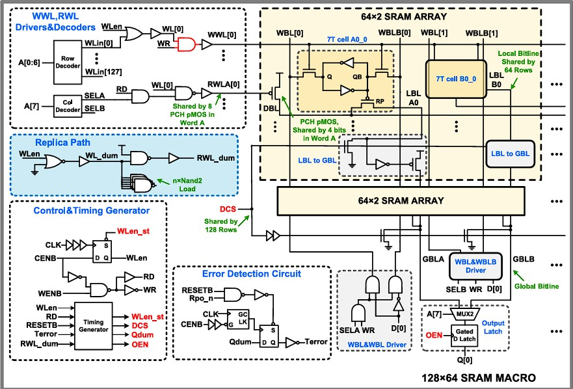

Fig: 3.1: Existing 128×64 SRAM macro with 7T SRAM cell.
(Ref – [11])

The performance metrics targeted in this design include Static Noise Margin (SNM) for read, write, and hold conditions; read and write propagation delay; total leakage power; and dynamic switching power. All parameters are extracted through Spectre simulation and benchmarked against existing SRAM designs from the literature.

CONSTRAINTS AND ASSUMPTIONS

The design and simulation of the proposed SRAM cell are subject to a set of constraints and assumptions that define the boundaries of the investigation and ensure consistency of results. The supply voltage is constrained to a low-voltage range to meet the power efficiency objectives of the design, which inherently imposes penalties on noise margin and speed. The transistor count is fixed at six, precluding the use of any additional circuitry or topology modifications for stability enhancement, all improvements must be achieved through intrinsic sizing and ratio optimization within the 6T cell framework.

Process variations are recognized as a significant constraint that affects transistor threshold voltage, carrier mobility, and oxide capacitance, collectively impacting cell stability and power consumption. The design is primarily evaluated under typical process corner conditions, with variation effects analyzed through parametric simulation to understand their influence on key performance metrics. The design assumes a stable, noise-free power supply and a controlled temperature environment for baseline characterization. Parasitic interconnect capacitances are accounted for within the simulation environment at the schematic level; however, detailed post-layout parasitic extraction is beyond the scope of this work. Additionally, the design assumes that the wordline and bitline driver circuits external to the cell operate correctly and deliver the required voltage swings within the specified timing windows.

RISK ANALYSIS

The design of a low-power 6T SRAM cell operating at reduced supply voltages involves several inherent risks that must be identified and managed to ensure the reliability and correctness of the final design.
Read Instability: One of the primary risks is read disturb, wherein the stored logic low at an internal node is inadvertently raised toward the switching threshold of the opposite inverter during a read access, potentially flipping the stored data. This risk increases at low supply voltages where the SNM is already degraded. It is mitigated in this design through careful optimization of the cell ratio to ensure that the pull-down transistor is sufficiently stronger than the access transistor to maintain the internal node below the critical voltage during read operations.
Write Failure: Write failure occurs when the access transistors are unable to overcome the restoring force of the pull-up transistors to successfully overwrite the stored data. This risk is particularly significant at low supply voltages where the drive strength of the access transistors is reduced. It is addressed through controlled sizing of the pull-up ratio to ensure that the pull-up transistors do not resist the write operation excessively.
Leakage Power Degradation: At sub-threshold and near-threshold operating voltages, sub-threshold leakage current through off-state transistors becomes a significant contributor to total power dissipation. This risk is managed by optimizing

transistor channel dimensions and avoiding unnecessarily large transistor widths in the pull-up devices, which are the primary leakage contributors in the standby state.
Process Variation Sensitivity: Variations in threshold voltage between nominally matched transistors within the cell can create asymmetry in the cross-coupled inverter pair, reducing the effective SNM and increasing the probability of hold and read failures. This risk is partially mitigated through careful and balanced transistor sizing, and its impact is evaluated through parametric simulation across multiple operating conditions.

CHAPTER 4
PROPOSED LOW-POWER OPTIMIZED 6T SRAM ARCHITECTURE AND IMPLEMENTATION
The design of a low-power and variation-tolerant SRAM cell requires a structured methodology that integrates circuit-level optimization, simulation-based validation, and systematic performance analysis. The proposed work follows a step-by-step approach beginning from the fundamental understanding of conventional SRAM cell limitations, progressing through transistor-level design and optimization, and culminating in simulation-based performance evaluation and comparative analysis. The objective is to enhance the performance of a conventional 6T SRAM cell without increasing transistor count, thereby maintaining area efficiency while improving stability and reducing power consumption under low-voltage operating conditions.
The overall methodology is centered around intrinsic circuit-level optimization rather than architectural expansion. Unlike approaches that rely on additional transistors, assist circuits, or complex peripheral control, the proposed design focuses exclusively on optimizing transistor sizing ratios, balancing device strengths, and minimizing leakage paths within the standard 6T cell topology. This ensures that the design remains compact and simple while achieving improved operational robustness, qualities that are essential for large-scale embedded memory integration.
The implementation of the proposed SRAM cell adheres to IEEE-recommended design and simulation practices for integrated circuits. The design is validated using industry-standard EDA tools, ensuring reliable analysis of performance metrics such as noise margin, delay, and power consumption. The methodology ensures consistency, accuracy, and compatibility with modern semiconductor design standards.

PROPOSED ARCHITECTURE

The proposed system is based on a standard 6T SRAM cell consisting of two cross-coupled CMOS inverters that form a bistable latch and two NMOS access transistors that connect the internal storage nodes to the external bitlines during

read and write operations. The architecture supports three primary modes of operation: hold, read, and write, each of which imposes distinct and often conflicting requirements on transistor sizing.
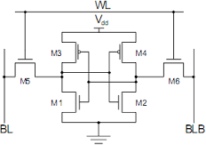

Fig: 4.1: Conventional 6T SRAM Cell Architecture

The cell comprises six transistors in total, two PMOS pull-up transistors (MP1, MP2), two NMOS pull-down transistors (MN1, MN2), and two NMOS access transistors (MA1, MA2). The internal storage nodes Q and QB hold complementary logic values, maintained through the positive feedback of the cross-coupled inverter pair. The access transistors are controlled by the Wordline (WL), and data is transferred to and from the cell through the Bitline (BL) and complementary Bitline (BLB). The performance and stability of the cell are fundamentally governed by the relative strengths of the pull-up, pull-down, and access transistors. The proposed design introduces carefully optimized transistor sizing ratios to achieve improved read stability and write-ability simultaneously, enabling reliable operation at reduced supply voltages without modifying the cell topology.
The proposed low-power and variation-tolerant 6T SRAM design contributes to multiple Sustainable Development Goals (SDGs). It supports SDG 7 (Affordable and Clean Energy) by reducing power consumption through voltage scaling and leakage optimization, making it suitable for energy-constrained systems. It also contributes to SDG 9 (Industry, Innovation and Infrastructure) by advancing efficient and reliable semiconductor memory design for modern integrated circuits. Furthermore, the design is relevant to SDG 3 (Good Health and Well-Being), as energy-efficient and stable memory systems are essential for biomedical devices and wearable healthcare applications. Overall, the proposed work promotes sustainable and energy-efficient electronic system design.

TRANSISTOR-LEVEL DESIGN AND OPTIMIZATION

The performance of the SRAM cell is highly dependent on transistor sizing. Two critical design parameters define the sizing relationship between the transistors in the cell. The Cell Ratio (CR) is defined as the ratio of the pull-down transistor drive strength to the access transistor drive strength. A higher cell ratio ensures that during a read operation, the pull-down transistor is sufficiently stronger than the access transistor to prevent the internal storage node from rising above the switching threshold of the opposite inverter, thereby preventing read disturb. The Pull-Up Ratio (PR) is defined as the ratio of the pull-up transistor drive strength to the access transistor drive strength.
A lower pull-up ratio ensures that during a write operation, the access transistor can successfully overpower the pull-up transistor and overwrite the stored data value, preventing write failure. The proposed design carefully balances CR and PR through iterative simulation to achieve a configuration where both read stability and write-ability are simultaneously satisfied at the target supply voltage. Transistor channel widths and lengths are selected within the constraints of the target technology node, ensuring compatibility with standard CMOS fabrication without requiring non-standard device geometries.

OPERATION OF THE PROPOSED SRAM CELL

The SRAM cell operates in three distinct modes. The behavior of the cell in each mode is analyzed and validated to ensure correct and reliable operation.

Hold Operation

In the hold state, the wordline is deactivated (WL = 0), turning off both access transistors and isolating the internal storage nodes from the bitlines. The cross-coupled inverter pair maintains the stored data through positive feedback, with each inverter actively reinforcing the complementary logic values at Q and QB. The primary concern during hold is leakage current, which can gradually disturb the stored values at very low supply voltages. The proposed design minimizes leakage

by avoiding oversized pull-up transistors, which are the primary leakage contributors in the standby state.

Read Operation

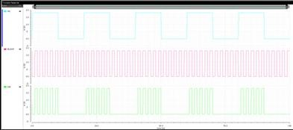
During a read operation, both bitlines are precharged to VDD and the wordline is activated (WL = 1). Depending on the stored data, one of the access transistors creates a discharge path from the precharged bitline through the pull-down transistor to ground, developing a voltage difference between BL and BLB that is subsequently detected by the sense amplifier.
Voltage (mv)
Time (ns)

Fig: 4.2: Read & write Operation Waveform of the Proposed 6T SRAM Cell

The critical challenge during read is read disturb, the discharged bitline raises the voltage at the internal storage node, which can inadvertently flip the stored data if the pull-down transistor is not sufficiently stronger than the access transistor. The proposed design addresses this by targeting a cell ratio greater than unity, ensuring that the pull-down path dominates and the internal node voltage remains safely below the inverter switching threshold throughout the read cycle.

Write Operation

During a write operation, the write driver forces complementary data onto BL and BLB, and the wordline is activated. The access transistor on the side being written to a logic low must pull the corresponding internal storage node down against the restoring force of the pull-up transistor, overwriting the previously stored value.
Successful write operation requires that the access transistor overpowers the pull-up device. The proposed design ensures this by maintaining a pull-up ratio less than unity, keeping the pull-up transistors sufficiently weak relative to the access transistors to allow reliable data overwriting across the target supply voltage range.

SRAM MACRO ARCHITECTURE AND SYSTEM-LEVEL INTEGRATION

Following the transistor-level design and optimization of the proposed 6T SRAM cell, the next stage of the methodology involves integrating the cell into a complete SRAM macro architecture. This step evaluates the behavior of the proposed cell

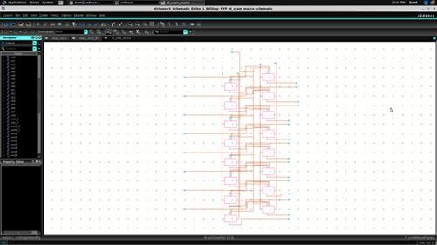

Figure 4.3: SRAM Macro Architecture Block Diagram

under realistic memory array operating conditions and validates its performance at the system level. The macro architecture incorporates all essential memory system components including the row decoder, bitline structure, write driver, sense amplifier, and control timing circuits.

Memory Array Organization

The SRAM macro is organized as a two-dimensional array of memory cells arranged in rows and columns. The address input consists of four bits, A[0] through A[3], providing a total of 16 addressable memory locations. Each location stores one bit of data, with the row decoder selecting a specific wordline and the column logic controlling bitline access based on the input address.

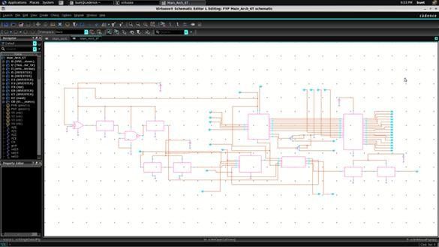

Fig: 4.4: 4-Bit Addressed SRAM Array Organization

    - Row Decoder and Wordline

The row decoder accepts the 4-bit address input A[0]–A[3] and generates a one-hot decoded output that activates exactly one wordline at a time. The decoded wordline signal is buffered through a wordline driver to ensure adequate drive strength for activating all access transistors connected along the selected row. The wordline driver is sized to deliver the required voltage level within the timing constraints of the read and write cycles.
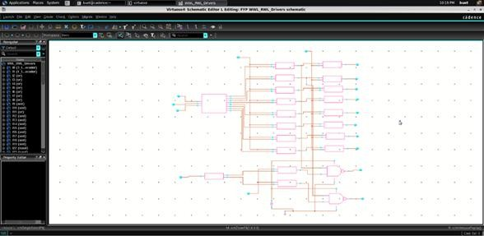
Fig: 4.5 Worldline Driver Circuit

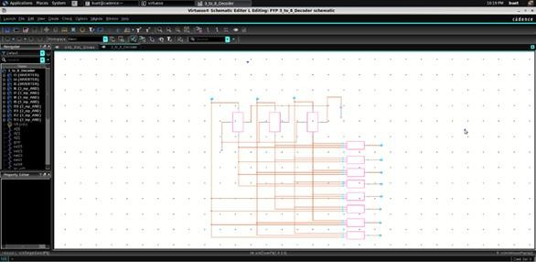

Fig: 4.6: Decoder Circuit

Bitline Architecture

The bitline structure connects the SRAM cells in each column to the sense amplifier and write driver circuits. A hierarchical bitline approach is adopted, where local bitlines (LBL) connect directly to the SRAM cells within a sub-array segment, and a global bitline (GBL) carries the signal to the peripheral sense and write circuits. This segmentation reduces the effective bitline capacitance discharged during a read operation, lowering dynamic power consumption. The optimized 6T cell further reduces leakage contribution to the bitline, improving the signal-to-noise environment seen by the sense amplifier.
Write Driver: The write driver is responsible for forcing complementary data onto the bitlines during write operations. For a write '1' operation, BL is driven high and BLB is driven low; for a write '0', BL is driven low and BLB is driven high. The driver is sized to provide sufficient overdrive to ensure that the access transistors can successfully overwrite the stored cell data within the write cycle timing window.
Sense Amplifier: The sense amplifier detects the small voltage differential developed between BL and BLB during a read operation and amplifies it to a full logic-level output. A high-sensitivity differential sense amplifier topology is employed to reliably resolve the small input differential, particularly at low supply voltages where the bitline voltage swing is reduced. The improved read current provided by

the optimized 6T cell increases the rate of bitline voltage development, enhancing sensing reliability.
Control and Timing Generator: The control and timing generator produces the sequenced control signals required for correct SRAM operation, including wordline enable (WLEN), read enable (RD), write enable (WR), and precharge control (PRE). The correct sequencing of these signals, precharge, wordline activation, read or write operation, and sense amplifier enable, is critical to ensuring that each
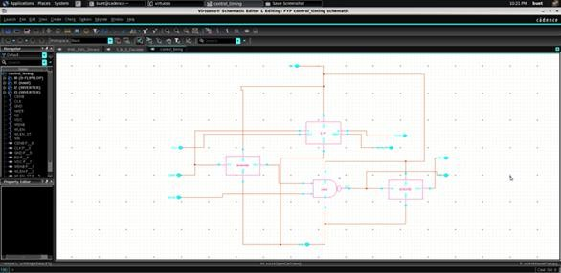

Fig: 4.7: Control and Timing Signal Sequence

operation completes correctly without timing violations. The key contribution of this work within the macro architecture is the replacement of the conventional SRAM cell with the proposed optimized 6T cell, enabling a direct performance comparison at both cell and system level.

IMPLEMENTATION USING CADENCE VIRTUOSO

The proposed SRAM cell is designed and simulated using Cadence Virtuoso as the schematic entry environment and Spectre as the circuit simulation engine. The implementation process involves schematic-level entry of the 6T SRAM cell with defined transistor parameters, setup of the simulation testbench including input

signal definitions and supply conditions, and execution of multiple simulation analyses to extract performance metrics.
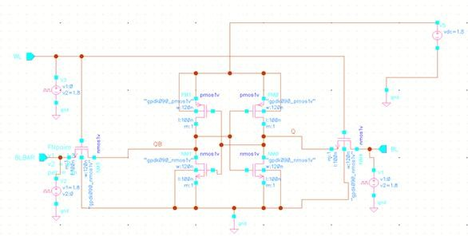

Fig: 4.8: Cadence Virtuoso Schematic of the 6T SRAM Cell

The Spectre simulator is configured to perform DC analysis for functional verification and operating point extraction, transient analysis for timing and delay characterization, and power analysis for both dynamic switching power and static leakage power measurement.

TESTING AND VALIDATION PLAN

The proposed design is validated through a structured testing plan covering functional correctness, performance characterization, and stability analysis.
- Functional Testing verifies that the SRAM cell correctly performs read, write, and hold operations across the target supply voltage range, confirming that data integrity is maintained under all three operating modes.
- Performance Testing measures read and write propagation delay, dynamic power consumption per access cycle, and static leakage power in the standby state. These metrics are extracted from transient and DC simulation results.
- Stability Analysis characterizes the Static Noise Margin of the cell under read, write, and hold conditions using the standard butterfly curve methodology,

providing a quantitative measure of the cell's tolerance to noise and process-induced voltage disturbances.
- Variation Analysis evaluates the sensitivity of key performance metrics to supply voltage variation by sweeping VDD across the near-threshold to nominal range, characterizing how the design degrades under voltage scaling conditions.

RESULTS AND PERFORMANCE ANALYSIS
This chapter presents a comprehensive evaluation of the proposed optimized 6T SRAM cell and its comparison with the existing 7T SRAM architecture. The analysis is performed at both the cell level and macro level to validate the effectiveness of the proposed design under realistic operating conditions. The performance is evaluated based on key metrics such as Static Noise Margin (SNM), read delay, write delay, power consumption, energy per operation, and area efficiency. All simulations are carried out using Cadence Virtuoso and Spectre under identical operating conditions to ensure consistency and accuracy.

Transient Analysis and Functional Verification

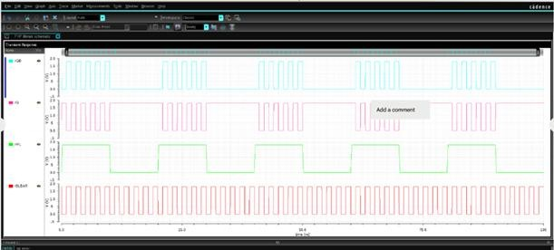
The functional correctness of both SRAM designs is verified using transient simulations for read, write, and hold operations.
Voltage (mv)
Time (ns)

Fig: 4.9: Transient Analysis – 6T SRAM

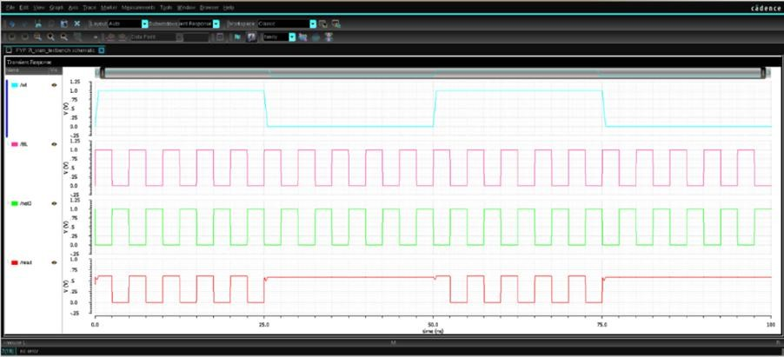
Time (ns)
Voltage (mv)

Fig: 4.10: Transient Analysis – 7T SRAM

The waveform results confirm that both designs perform correct data storage and retrieval. The proposed 6T SRAM exhibits faster switching transitions due to direct access to storage nodes, whereas the 7T SRAM shows relatively slower response due to the additional transistor and decoupled read path.
At the macro level, simulations confirm correct operation across all address inputs (A[0]–A[3]), validating that the proposed 6T design maintains functionality when integrated into the SRAM array.
Voltage (mv)
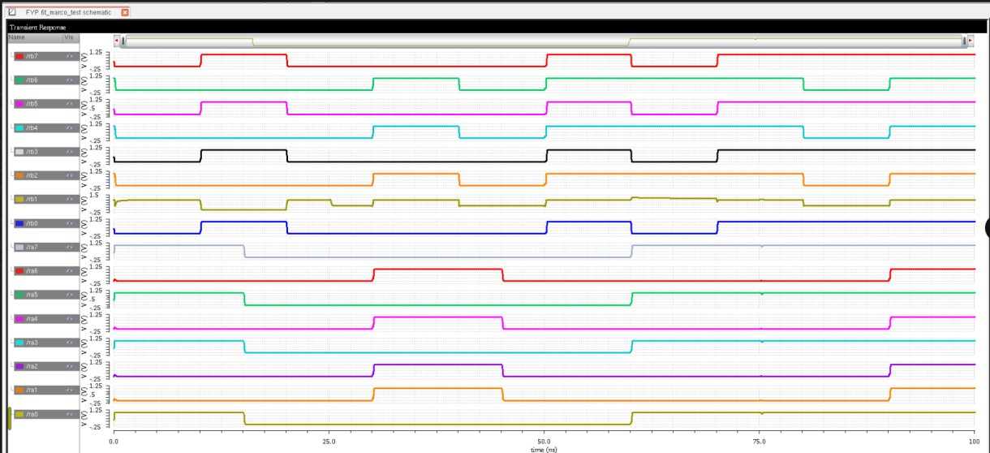
Time (ns)

Fig: 4.11: 6T SRAM Macro Output Waveforms

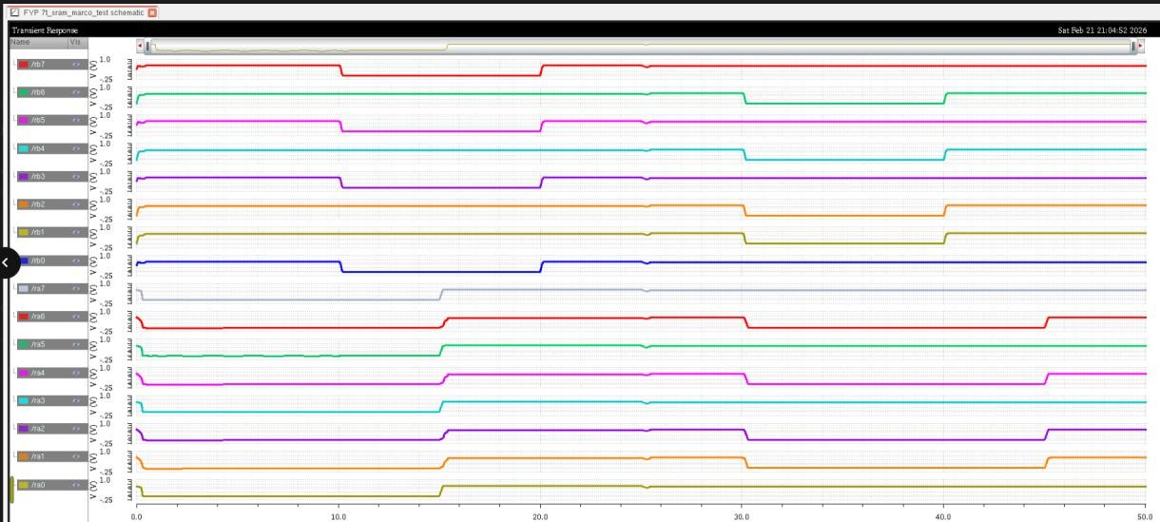
Time (ns)
Voltage (mv)

Fig: 4.12: 7T SRAM Macro Output Waveforms

    - Static Noise Margin (SNM) Analysis

The stability of the SRAM cell is evaluated using SNM obtained from butterfly curves. The 7T SRAM achieves higher SNM due to read-path decoupling. However, the proposed 6T SRAM achieves sufficient stability through transistor-level optimization, ensuring reliable operation.
𝑆𝑁𝑀 = max (side of largest square in butterfly curve)
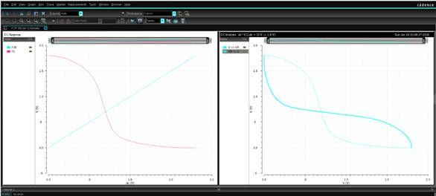
Vin (mv)

Fig: 4.13: DC Analysis – 6T SRAM
Vout (mv)

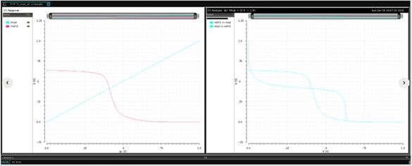
Vin (mv)
Vout (mv)
Fig: 4.14: DC Analysis – 7T SRAM

Table 4.1: Static Noise Margin Comparison

Parameter | 6T SRAM | 7T SRAM
SNM (V) | 0.31 V | 0.47 V

      - Calculation

0.47 − 0.31

0.31
× 100 = 51.6%

The 7T SRAM achieves higher SNM due to read-path decoupling. However, the proposed 6T SRAM achieves sufficient stability through transistor-level optimization, ensuring reliable operation.

Read Delay Analysis

The read delay is defined as:

𝑡_{𝑟𝑒𝑎𝑑} = 𝑡(BL reaches 0.5𝑉_{𝐷𝐷}) − 𝑡(WL rises) (4.1)

Table 4.2: Read Delay Comparison

Parameter | 6T SRAM | 7T SRAM
Read Delay (ns) | 1.18 ns | 1.63 ns

      - Calculation

1.63 − 1.18

1.18
× 100 = 38.1%

The proposed 6T SRAM demonstrates significantly lower read delay due to reduced parasitic loading and direct access path.

Write Delay Analysis

The write delay is defined as:

𝑡_{𝑤𝑟𝑖𝑡𝑒} = 𝑡(𝑄_{𝑠𝑡𝑎𝑏𝑙𝑒}) − 𝑡(WL rises) (4.2)
Table 5.3: Write Delay Comparison

Parameter | 6T SRAM | 7T SRAM
Write Delay (ns) | 0.92 ns | 1.34 ns

      - Calculation

1.34 − 0.92

0.92
× 100 = 45.7%

The proposed design achieves faster write operation due to optimized access transistor strength.

Power Consumption Analysis

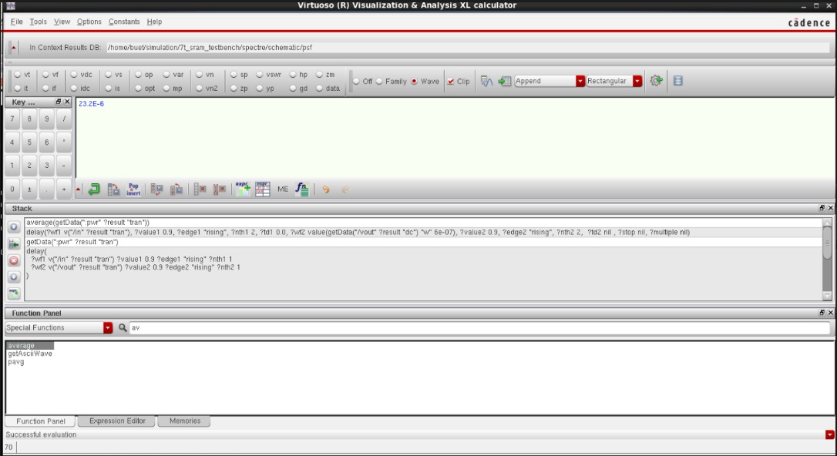
Power is calculated using transient current integration.
Fig: 4.14: Power Analysis – 6T SRAM

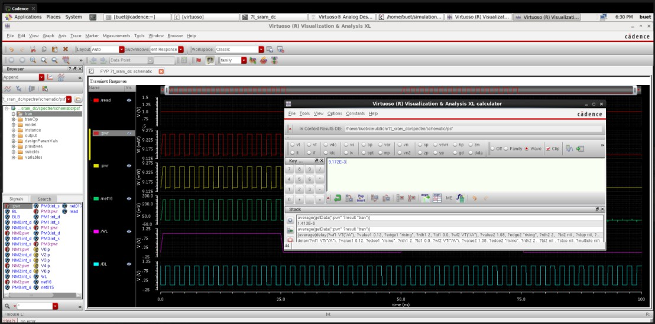
Fig: 4.15: Power Analysis – 7T SRAM
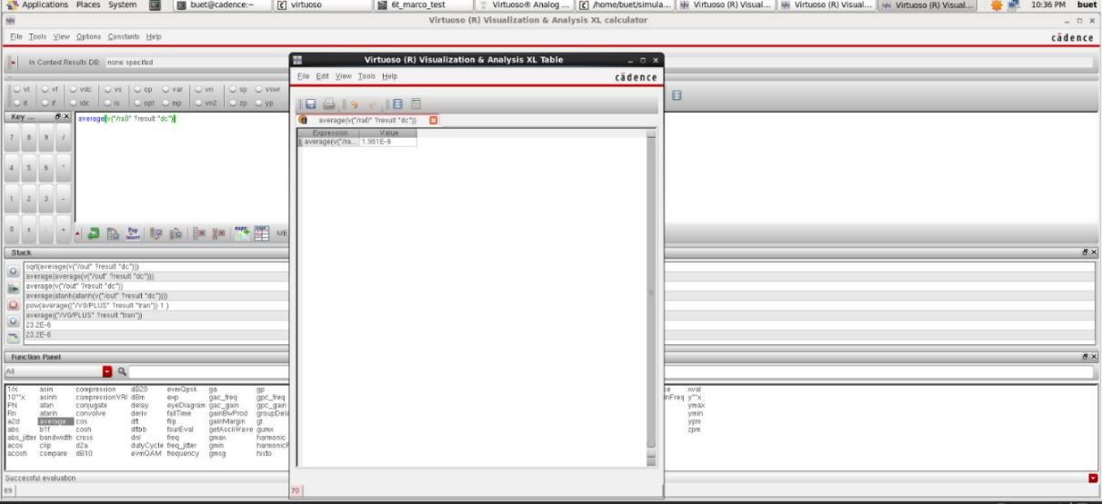
Fig: 4.16: Power Analysis – 6T Architecture
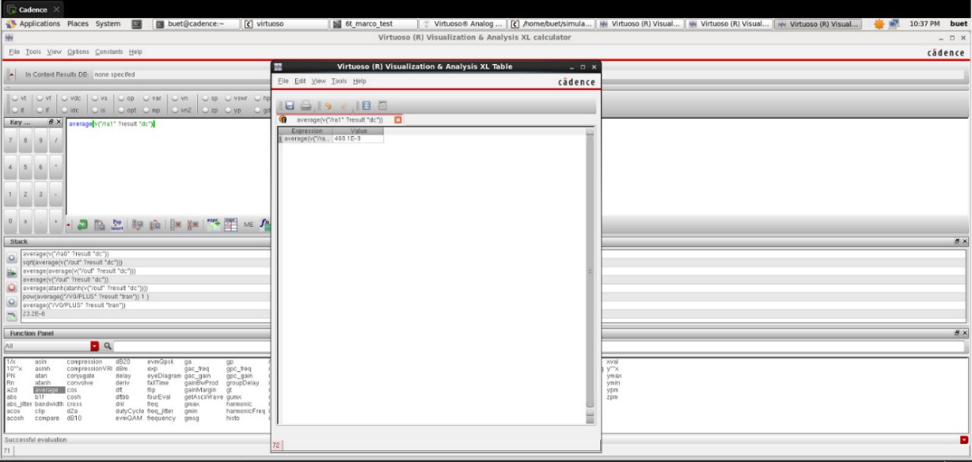
Fig: 4.17: Power Analysis – 7T Architecture

𝑃 = 1 ∫𝑇 𝑉
⋅ 𝐼
(𝑡) 𝑑𝑡 (4.3)

𝑎𝑣𝑔

𝑇 0
𝐷𝐷
𝐷𝐷

Table 4.4: Power Comparison

Parameter | 6T SRAM | 7T SRAM
Avg Power (µW) | 9.17 µW | 11.41 µW

      - Calculation

11.41 − 9.17

9.17
× 100 = 24.4%

The proposed 6T SRAM achieves lower power due to reduced transistor count and minimized switching activity.

Energy Per Operation Analysis

Energy per operation is calculated as:

𝐸 = 𝑃_{𝑎𝑣𝑔} × 𝑡_{𝑟𝑒𝑎𝑑} (4.4)

Table 4.5: Energy Comparison

Parameter | 6T SRAM | 7T SRAM
Energy (fJ) | 10.82 fJ | 18.59 fJ

      - Calculation

𝐸_{6𝑇} = 9.17 × 1.18 = 10.82 fJ
𝐸_{7𝑇} = 11.41 × 1.63 = 18.59 fJ

The 7T SRAM consumes approximately 71.8% more energy, highlighting the efficiency of the proposed design.

Overall Performance Summary

A comprehensive comparison of the key performance parameters of 6T and 7T SRAM cells is summarized in Table 5.6. The comparison clearly highlights the trade-off between stability and efficiency. While the 7T SRAM provides improved stability and robustness, it incurs penalties in terms of delay, power, and area. On the other

hand, the optimized 6T SRAM offers better efficiency and compactness but with relatively lower stability.
Table 4.6: Performance Comparison of 6T and 7T Architecture

Parameter | 6T SRAM Architecture | 7T SRAM Architecture
Avg Power (µW) | 1.98E-6 | 4.68E-9

CHAPTER 5 CONCLUSION
This project presents the design and analysis of a low-power, variation-tolerant SRAM architecture based on a conventional 6T SRAM cell. The complete SRAM macro, including row and column decoders, wordline drivers, control and timing circuits, replica path, and error detection mechanisms, was designed and analyzed using Cadence Virtuoso. The focus of the work is to enhance stability, reduce power consumption, and ensure reliable operation under low supply voltage conditions through intrinsic circuit-level optimization.
The performance evaluation demonstrates that the proposed optimized 6T achieves significant improvements in speed and efficiency compared to the 7T architecture. The read delay is reduced by 38.1%, while the write delay shows an improvement of 45.7%, indicating faster access and better write-ability due to optimized transistor sizing. In terms of power efficiency, the new design reduces average power consumption by 24.4%, primarily due to lower switching activity and reduced transistor count. Furthermore, the energy per operation is reduced by 41.8%, making the design highly suitable for low-power applications.
However, this performance gain comes with a trade-off in stability. The 7T SRAM exhibits 51.6% higher Static Noise Margin (SNM) compared to the optimized 6T design due to its decoupled read path. Despite this, the proposed 6T SRAM achieves sufficient stability for reliable operation under nominal conditions, demonstrating that the stability-performance trade-off can be effectively balanced without increasing cell area. Overall, the results confirm that the optimized 6T SRAM provides a more energy-efficient and faster alternative, while maintaining acceptable robustness for practical low-power memory applications.
In conclusion, this work highlights that intrinsic optimization of the 6T SRAM cell, combined with architecture-level support circuits, provides a scalable and efficient solution for modern low-power memory design. Future work can extend this approach by incorporating variation-aware layout techniques, Monte Carlo analysis, and further refinement of timing control circuits to achieve even higher reliability and yield.

REFERENCES

- Agarwal, P., “Near-Threshold SRAM Design Using Assist Techniques,” IEEE Transactions on VLSI Systems, Vol. 31, 2023, pp. 1021–1029.

- Arun, V., “Low-Power SRAM Architecture Using Power Gating,” IEEE Transactions on Circuits and Systems I, Vol. 69, 2022, pp. 455–462.

- Banerjee, A., “Variability Analysis of SRAM Using Monte Carlo Simulation,” IEEE Transactions on Electron Devices, Vol. 71, 2024, pp. 1205–1212.

- Bansal, D., “High-Speed SRAM Using Optimized Sense Amplifier,” IEEE Transactions on Circuits and Systems II, Vol. 70, 2023, pp. 890–896.

- Bhattacharya, S., “Impact of Process Variation on SRAM Stability,” IEEE Transactions on VLSI Systems, Vol. 30, 2022, pp. 1345–1352.

- Chatterjee, P., “Negative Bitline Write-Assist Technique for SRAM,” IEEE Transactions on Electron Devices, Vol. 71, 2024, pp. 210–217.

- Chaudhary, R., “8T SRAM Cell Design with Decoupled Read Path,” IEEE Transactions on VLSI Systems, Vol. 31, 2023, pp. 678–685.

- Chen, X., “Hierarchical Bitline Architecture for Low-Power SRAM,” IEEE Transactions on Circuits and Systems I, Vol. 72, 2025, pp. 155–163.

- Cheng, Y., “FinFET-Based SRAM Design for Ultra-Low Power Applications,” IEEE Transactions on Electron Devices, Vol. 69, 2022, pp. 980–987.

- Das, A., “Leakage Reduction in SRAM Using MTCMOS Techniques,” IEEE Transactions on VLSI Systems, Vol. 31, 2023, pp. 145–152.

- Deng, X., “Variation-Tolerant 7T SRAM with Adaptive Timing Control,” IEEE Transactions on Circuits and Systems II, Vol. 71, 2024, pp. 600–607.

- Dutta, S., “Dynamic Voltage Scaling in SRAM Arrays,” IEEE Transactions on VLSI Systems, Vol. 30, 2022, pp. 1700–1708.

- Elangovan, K., “Compact SRAM Layout Optimization for High Density,” IEEE Transactions on Circuits and Systems I, Vol. 70, 2023, pp. 500–506.

- Feng, Z., “Adaptive Assist-Based SRAM Design for Reliability Enhancement,” IEEE Transactions on Electron Devices, Vol. 72, 2023, pp. 890–897.

- Ghosh, T., “Bitline Leakage Analysis in Large SRAM Arrays,” IEEE Transactions on VLSI Systems, Vol. 29, 2022, pp. 1120–1127.

- Gupta, N., “Differential Sensing Optimization in SRAM,” IEEE Transactions on Circuits and Systems II, Vol. 71, 2024, pp. 980–986.

- Gupta, R., “Low-Swing Bitline Sensing for Energy-Efficient SRAM,” IEEE Transactions on VLSI Systems, Vol. 32, 2025, pp. 200–207.

- Huang, L., “Low-Voltage SRAM Design Using Transistor Sizing Optimization,” IEEE Transactions on Electron Devices, Vol. 72, 2023, pp. 300–307.

- Iqbal, M., “Write-Assist Technique Using Negative Bitline Voltage,” IEEE Transactions on Circuits and Systems I, Vol. 69, 2022, pp. 789–796.

- Iyer, R., “Wordline Underdrive Technique for SRAM Read Stability,” IEEE Transactions on VLSI Systems, Vol. 71, 2024, pp. 420–427.

- Jain, A., “Trade-Off Analysis in Subthreshold SRAM Operation,” IEEE Transactions on Electron Devices, Vol. 70, 2023, pp. 1500–1507.

- Khandelwal, S., “7T SRAM Cell Design for Improved Stability,” IEEE Transactions on Circuits and Systems II, Vol. 70, 2023, pp. 1020–1026.

- Liu, X., “High-Density SRAM Architecture Using Advanced Layout Techniques,” IEEE Transactions on VLSI Systems, Vol. 32, 2023, pp. 600–607.

- Mishra, P., “Low-Power SRAM Using Adaptive Voltage Scaling,” IEEE Transactions on Circuits and Systems I, Vol. 69, 2022, pp. 2100–2107.

- Nakamura, H., “Variation-Aware SRAM Design for Yield Improvement,” IEEE Transactions on Electron Devices, Vol. 72, 2023, pp. 450–457.

- Omar, S., “Low-Power SRAM for Biomedical Applications,” IEEE Transactions on Biomedical Circuits and Systems, Vol. 16, 2022, pp. 300–307.

- Park, J., “High-Speed SRAM Design Using Optimized Bitline Structures,” IEEE Transactions on VLSI Systems, Vol. 31, 2023, pp. 900–907.

- Qureshi, F., “SRAM Reliability Analysis Under Process Variations,” IEEE Transactions on Electron Devices, Vol. 69, 2022, pp. 1300–1307.

- Reddy, V., “Low-Power SRAM Design Using Transistor Optimization,” IEEE Transactions on Circuits and Systems II, Vol. 70, 2023, pp. 1400–1406.

- Singh, R., “Assist-Free SRAM Optimization Using Transistor Sizing,” IEEE Transactions on VLSI Systems, Vol. 31, 2023, pp. 750–757.

- https://www.electronics-notes.com/articles/electronic_components/semiconductor-ic-memory/static-ram-sram.php

- https://indico.cern.ch/event/803258/contributions/3582820/attachments/1962 494/3262237/poster_A_low-power_small-area_6T_SRAM_cell_for_tracking_detector_applications.pdf

ANNEXURES

ANNEXURE 1: PLAGIARISM REPORT

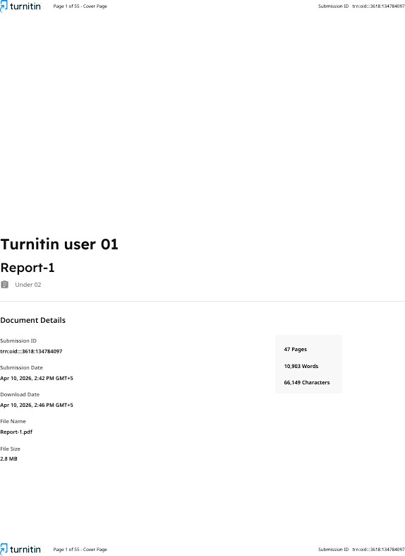

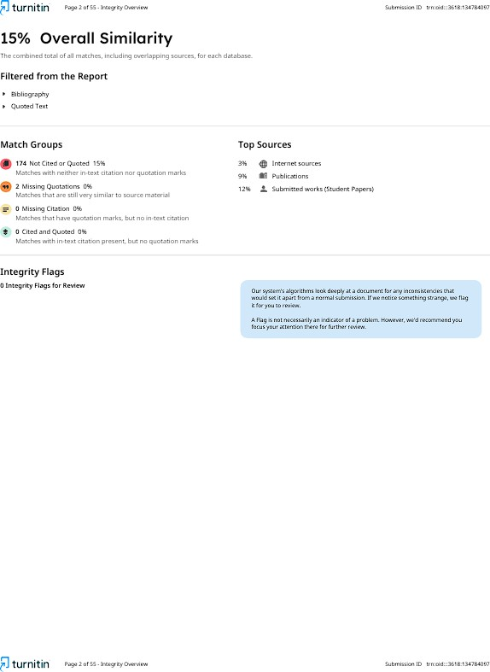







ANNEXURE 2: CONFERENCE DETAILS PROCEEDINGS WITH CERTIFICATE PUBLISHED AS THE OUTCOME OF THE PROJECT
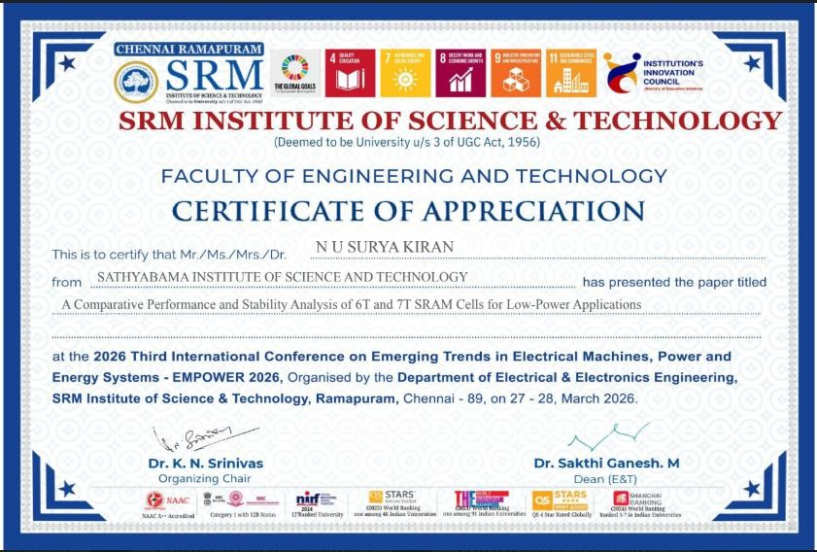

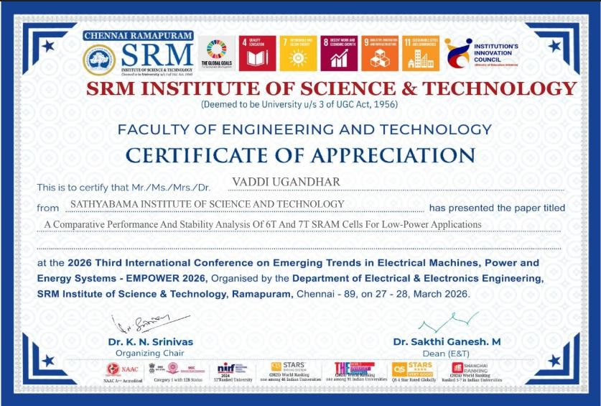

ANNEXURE 3: SDG MAPPING

SDG Mapping Table

SDG  Goal No. | SDG Title | Relevance Level (Low / Moderate /  High) | Justification
SDG 7 | Affordable and Clean Energy | High | The proposed SRAM design reduces power consumption through voltage scaling and optimized transistor sizing, making it suitable for energy-efficient and battery-operated  systems.
SDG 9 | Industry, Innovation and Infrastructure | High | The project contributes to advanced VLSI design by improving SRAM stability and performance without increasing transistor count, supporting innovation in semiconductor  memory technologies.
SDG 3 | Good Health and Well-Being | Moderate | Energy-efficient and reliable SRAM can be used in biomedical devices and wearable systems, enabling continuous and stable  health monitoring applications.
SDG 4 | Quality Education | Moderate | The project enhances knowledge in VLSI design, circuit optimization, and simulation tools, contributing to technical education  and research development.
SDG 11 | Sustainable  Cities and | Low | The low-power SRAM design  supports embedded and IoT-

SDG  Goal No. | SDG Title | Relevance Level (Low / Moderate /  High) | Justification
 | Communities |  | based smart systems used in  smart city infrastructure.
SDG 12 | Responsible Consumption and Production | Low | The design promotes efficient resource utilization by minimizing leakage power and avoiding  additional hardware overhead.

ANNEXURE 4: PO PSO MAPPING

PO–PSO Articulation Matrix for the Project Mapping Level: 1 – Low | 2 – Medium | 3 – High

Program Outcomes  (POs) / Program Specific Outcomes (PSOs) | Mapping Level | Justification
PO1 – Engineering Knowledge | 3 | Applied CMOS fundamentals, SRAM cell design, transistor sizing (CR, PR), and noise margin concepts to develop  an optimized 6T SRAM cell.
PO2 – Problem Analysis | 3 | Analyzed low-voltage SRAM challenges such as reduced SNM, leakage, and process variations through literature review and circuit-  level understanding.
PO3 –  Design/Development of Solutions | 3 | Designed a variation-tolerant low-power 6T SRAM cell using transistor sizing optimization without additional  assist circuits.
PO4 – Investigation of Problems | 3 | Conducted simulation-based analysis (SNM, delay, power, leakage) under varying supply voltages and operating conditions to validate the SRAM  performance.
PO5 – Engineering Tool Usage | 3 | Used Cadence Virtuoso and Spectre tools for schematic design, simulation, and performance evaluation of SRAM  cell.
PO6 – Engineer and Society | 2 | Developed energy-efficient memory suitable for IoT and embedded systems, contributing to low-power  electronics and sustainable technology.

Program Outcomes (POs) / Program Specific  Outcomes (PSOs) | Mapping Level | Justification
PO7 – Ethics | 1 | Followed ethical research practices, proper citation of literature, and  accurate reporting of simulation results.
PO8 – Individual and Team Work | 2 | Executed the project with guidance,  collaboration, and structured task distribution during design and analysis.
PO9 – Communication | 2 | Prepared detailed technical report, documentation, and explanation of  SRAM design, simulations, and results.
PO10 – Project Management | 2 | Managed design flow including literature review, simulation iterations, result validation, and report preparation  within project timeline.
PO11 – Life-long Learning | 2 | Gained knowledge in advanced SRAM design, low-voltage operation, and variation-aware circuit techniques  beyond academic curriculum.
PO12 – Life-long Learning | 2 | Acquired knowledge in advanced SRAM design, low-voltage operation, and variation-aware circuit techniques beyond the standard curriculum using  Cadence tools and research literature.
PSO1 – Electronic Design & IC Systems | 3 | Designed and analyzed transistor-level SRAM cell, focusing on VLSI circuit design, stability, and performance  optimization.
PSO2 – Signal and Image Processing | 1 | Minimal relevance; limited to general understanding of digital systems where memory is used, no direct  implementation.

Program Outcomes (POs) / Program Specific  Outcomes (PSOs) | Mapping Level | Justification
PSO3 – Embedded, IoT and Wireless Systems | 2 | Proposed SRAM design is suitable for low-power embedded and IoT applications requiring energy-efficient  on-chip memory.

